Longitudinal Analysis: Assessing the Impact of U.S. Justice System Expenditures on Crime Rates (2007 – 2017)

Brandon Bush

September 2024
_________________________________________________________________________________________________________

Introduction

According to the U.S. Bureau of Justice Statistics, in 2022, the United States imprisoned more than 1.8 million people, which equates to approximately 541 citizens out of every 100,000. The United States’ prison population is larger than any other country in the world, and more than twice the size of every country besides China. Mass incarceration has been a glaring issue for decades, with extremely harmful effects that continue to ravage communities all across the nation. While incarceration remains an enormous issue that needs to be addressed by American lawmakers, the goal of this project was to examine the efficacy of government spending across Washington D.C. and each of the 50 U.S. states in terms of reducing crime.
This analysis report focuses on a data sample that consists of every U.S. state, plus Washington D.C., in order to account for the diverse approaches that these semi-independent governments have taken towards minimizing criminal activity in their respective jurisdictions. In order to explore the longer-term effects of government expenditures, a recent 10-year timeframe was sought after to formulate a longitudinal study. After an initial period of research focused on finding consistent, credible, and officially recognized sources of data, two main data series were ultimately selected. These data series were used to create an initial panel data table in excel (Figure 1) that includes each of the 51 unique locations in the sample with recorded values for 15 different variables in 2007, 2012, and 2017.

About the Data Sources

The first source chosen was the Justice Expenditure and Employment Extracts (JEEE) Series, which is a Bureau of Justice Statistics (BJS) project that includes annual data derived from the U.S. Census Bureau's Annual Survey of State and Local Government Finances, and Annual Survey of Public Employment and Payroll. 3 separate issues of this series were used to compile data from the following 6 variables: Population; Expenditures Per Capita, All Government Functions; Expenditures Per Capita, Total Justice System; Expenditures Per Capita, Police Protection; Expenditures Per Capita, Judicial and Legal Functions; Expenditures Per Capita, Corrections.
The second source of raw data incorporated into this study was the F.B.I.’s Uniform Crime Reporting (UCR) program, which consolidates and summarizes annual crime data collected through the National Incident-Based Reporting System (NIBRS). This is a largescale effort orchestrated by the F.B.I. that establishes common crime definitions and brings together data from thousands of law enforcement agencies across the country. The NIBRS established a common framework for detailed crime data reporting that has been in place since 1989. For this study, 3 separate UCR data tables (1 from each year) were used to include data for the reported incidences of these 9 types of crime: Violent Crime; Murder and Non-negligent Manslaughter; Rape; Robbery; Aggravated Assault; Property Crime; Burglary; Larceny-theft; Motor Vehicle Theft.

Data Manipulation

After creating the initial table (Figure 1), the justice system expenditures column was divided by the total government expenditures column to start the formation of a new data frame. Next, the percentages of the total justice system funds allocated to each of the 3 categories outlined in the JEEE series were calculated. These 3 categories were Police; Judicial & Legal; and Corrections. Then, the following summary statistics were compiled into the following table.

Figure 2: Expenditures Table

The information in this table was used to create a number of visualizations that help reveal information about the relationships between these variables. In order to begin to observe possible shifts in how the state governments adjusted their budgets over the course of the decade, multiple time series box plots were created to observe these changes. Figure 3 is a group of box and whisker plots that illustrates how total government spending changed from 2007 to 2012, and 2017.

Figure 3
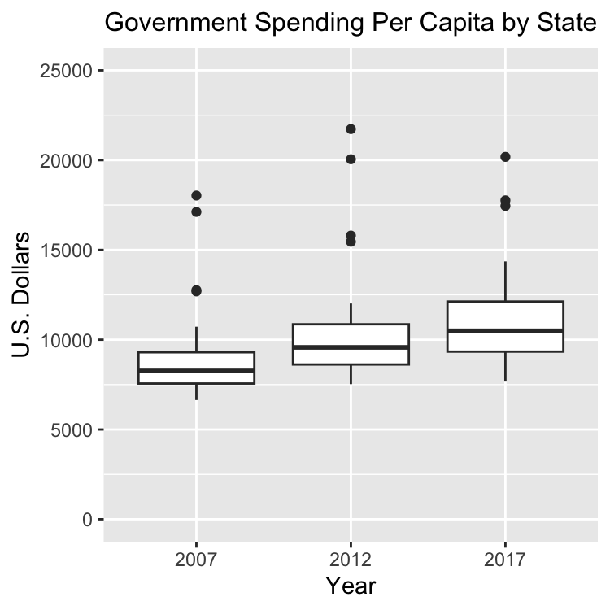
According to the Bureau of Labor Statistics (BLS), the value of the U.S. Dollar rose by approximately 17.37% from December 2007 to December 2017. In comparison, the mean level of government spending per capita grew to $11,797 in that same time period, which is a 33.79% increase. This shows that government expenditures outpaced the level of inflation from 2007 to 2017. Additionally, this boxplot reveals that there appeared to be a gradual increase in the level of variation among U.S. states when it came to government spending in 2017 compared to 2012 and 2007. From 2007 to 2012, the standard deviation escalated from 2,211.95 to 2,744.36. Then in 2017, it grew to 5,555.86. One major contributing factor for this is that Washington D.C. was a major outlier in 2017. During that year, total government spending per capita in D.C. skyrocketed to $46,675, which was more than double the next highest level recorded for any other location included in this study.
Next, Figure 4 sheds light on how the portion of total government funds directed towards the justice system decreased slightly during this time period.

Figures 4 and 5:
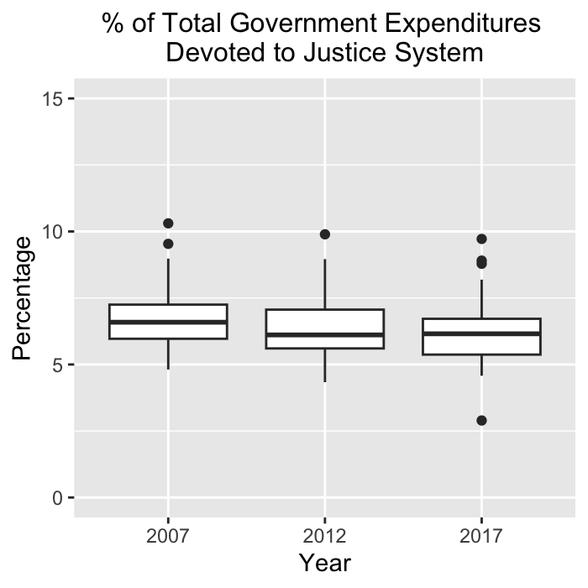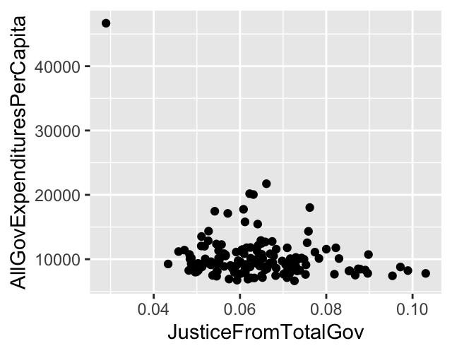

The data from Figure 2 shows that from 2007 to 2017, the median dropped by 0.4% and the mean fell by 0.5%. Additionally, the upper and lower quartiles, as well as the minimums and maximums all decreased at similar rates, which shows that the reduction in justice system spending as a portion of the total budget was mostly consistent throughout the entire sample. Figure 5 illustrates that the relationship between total expenditures per capita and the portion of expenditures spent by the justice system appears to demonstrate a normal distribution.
The other main takeaway pertaining to shifts in justice system expenditures from 2007 to 2017 was that while judicial and legal spending remained mainly constant during this time period, there was a general shift in funds from corrections towards policing. Police spending for the lower quartile grew by approximately 1%, but the median and upper quartiles both increased by nearly 3% over the course of this decade.
Given some of this context provided so far, an examination into the impact on crime rates began to emerge. Figure 6 is a correlation matrix that displays the linear relationships between 14 different variables included in this analysis.

Figure 6: Correlation Matrix (Expenditures and Crime Variables)
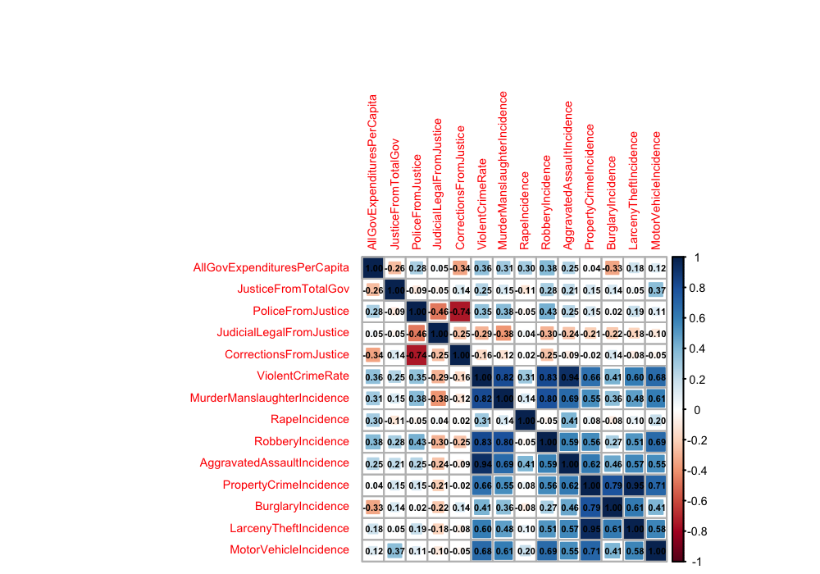

Figure 6 portrays the observed linear relationships between 14 different variables included in this analysis. Inside each box is a Pearson correlation coefficient, or “r-value,” which ranges between -1 and 1 depending on the “direction” and “strength” of the linear relationship between two variables. A negative correlation coefficient between two variables signifies that as one of the variables increases, the other variable generally decreases. A positive correlation coefficient signifies the opposite, meaning that both variables typically increase or decrease at the same time as each other. An r-value of zero means that there is absolutely no quantified linear correlation between the two variables at all. As negative r values get closer to -1, and positive r-values approach +1, the level of covariance between a random assortment of data points would be expected to decrease, and the data will tighten closer along the line of best fit.
A number of insights can be derived from the information provided by the correlation matrix that was created above. Perhaps the most apparent observation is that the nine different crime categories derived from the FBI’s NIBRS program almost all have a positive linear relationship. The only exception appears to be incidence levels of rape, which do not seem to have a strong linear relationship with any of the other 13 variables included.
Another noteworthy piece of information that can be derived from this matrix is that there is a positive correlation coefficient between the portion of total government expenditures allocated towards the justice system and 8 out of the 9 crime classifications listed. This suggests that states that devote a larger portion of their budget towards the justice system actually face higher levels of criminality. However, this does not automatically mean that there is a causal relationship between any these variables. Further analysis would be required to assess the benefits and drawbacks associated with determining how public sector funds should be allocated in order to reduce levels of crime.
Next, Figures 7, 8, and 9 were brought together to provide an alternative way to examine the relationships between violent crime and the 3 types of justice system spending.

Figures 7, 8, 9:

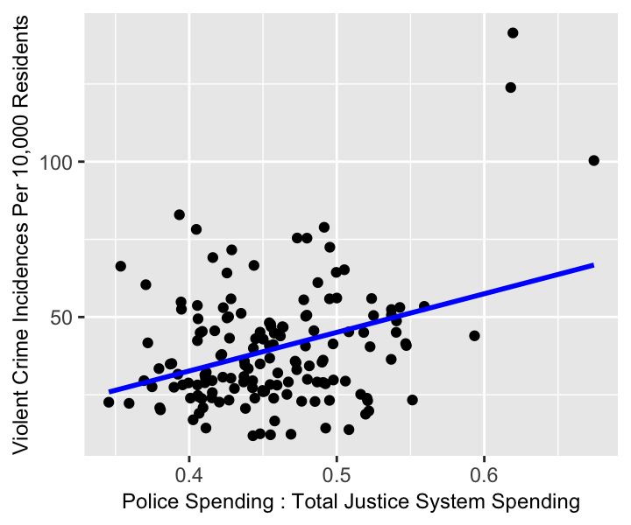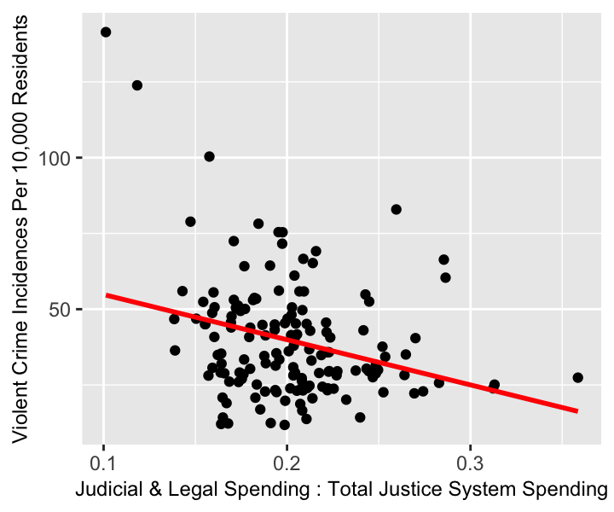

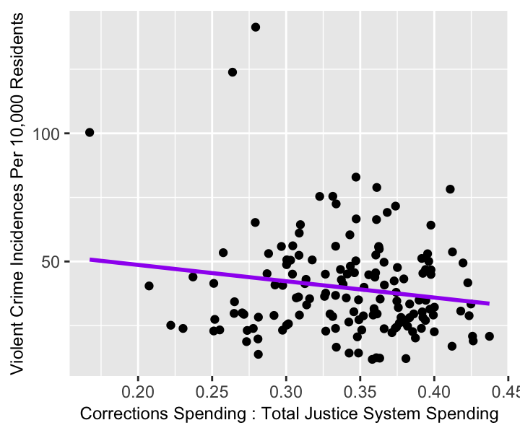

The scatterplots above include lines of best fit to highlight the general linear trends being displayed by the data points. From these 3 graphs, it appears as though there are somewhat significant patterns being shown in the data. The observations reveal that increasing the portion of spending on policing has a negative linear correlation with violent crime rate. In contrast spending on the two other categories of justice system expenditures have a positive correlation. These scatterplots also reveal that a linear regression may not be the best approach towards modelling this data due to the weak Pearson correlation coefficients.

Examining Individual States

One of the main reasons that a panel dataset was selected for this study was to identify whether or not certain patterns

specific states that have succeeded or failed in terms of reducing crime, and then investigate whether or not there are patterns showing how those states operate.

2017

Safest Large States

Safest Mid-Sized States

Safest Small States

States with Lowest Crime

States with Highest Crime

States with Most Efficient Outcomes

States with Least Efficient Outcomes

Limitations

A few minor inconsistencies needed to be addressed when bringing together the government expenditure data. One issue was that the expenditures per capita were calculated by the BJS and rounded to the nearest whole dollar in 2017, but not 2007 and 2012. Nevertheless, the 2007 and 2012 datasets did include population totals and total government expenditures for each state, which were used to find the per capita values for those years. Another minor issue was that the populations used by the JEEE data tables were slightly different than the populations included in the UCR. Since the difference between the population counts varied by less than 2% for every state, the JEEE population counts were arbitrarily selected as the only population measures in Figure 1, and all subsequent formulas that involved populations.

Recommendations

With everything considered, there are a number of takeaways that can inform researchers

Future Research

Going forward, it would make sense to continue tracking the variables from this study as newer data becomes available. Additionally, researchers could examine how justice system expenditures and crime rates evolved in shorter time periods where external factors like the COVID-19 pandemic affected all of the variables in this study. This could be achieved by selecting 1-year time increments between 2017 and 2027 instead of the 5-year increments observed in this study between 2007 and 2017.
Another interesting area to focus on could be incarceration and recidivism, which may help provide more context pertaining to the efficacy of each state’s justice system expenditures. Investing more money into rehabilitation efforts would likely reduce the financial burden on the state governments because it

Also look at crime solving rate

succeeding would help policymakers

_________________________________________________________________________________________________________

Data Tables and Visualizations
_________________________________________________________________________________________________________

Figure 1: Consolidated Data Table: Justice Expenditures and Crime (2007 – 2017)

Link: https://github.com/brandonbush12/Justice-System-Expenditures-Project/blob/main/Consolidated%20Data%20Crime%20and%20Expenditures.xlsx

Figure 2:

Works Cited

NIBRS data on crime

2017 National Incident-Based Reporting System
https://ucr.fbi.gov/nibrs/2017/tables/data-tables

2012 National Incident-Based Reporting System
https://ucr.fbi.gov/crime-in-the-u.s/2012/crime-in-the-u.s.-2012/tables/5tabledatadecpdf/table_5_crime_in_the_united_states_by_state_2012.xls

https://ucr.fbi.gov/nibrs/2012/data-tables

2007 National Incident-Based Reporting System
https://www.icpsr.umich.edu/web/NACJD/studies/25341
https://ucr.fbi.gov/crime-in-the-u.s/2007

FBI Uniform Crime Reporting Program

2017 Crime by U.S. State – Table 5
https://ucr.fbi.gov/crime-in-the-u.s/2017/crime-in-the-u.s.-2017/topic-pages/tables/table-5

1998 – 2017 Crime in the United States
https://ucr.fbi.gov/crime-in-the-u.s/2017/crime-in-the-u.s.-2017/topic-pages/tables/table-1

Justice Expenditures

https://bjs.ojp.gov/data-collection/justice-expenditure-and-employment-extracts-series

Justice Expenditures and Employment in the United States, 2017
https://bjs.ojp.gov/library/publications/justice-expenditures-and-employment-united-states-2017

https://bjs.ojp.gov/sites/g/files/xyckuh236/files/media/document/jeeus17.pdf

Justice Expenditures and Employment in the United States, 2012
https://bjs.ojp.gov/library/publications/justice-expenditure-and-employment-extracts-2012-final-update

Justice Expenditures and Employment in the United States, 2007
https://bjs.ojp.gov/library/publications/justice-expenditure-and-employment-extracts-2007-revised

Justice Expenditures and Employment in the United States, 1982 - 2007
https://bjs.ojp.gov/library/publications/justice-expenditures-and-employment-1982-2007-statistical-tables

https://www.prisonstudies.org/highest-to-lowest/prison-population-total?field_region_taxonomy_tid=All

BLS Inflation Calculator
https://data.bls.gov/cgi-bin/cpicalc.pl?cost1=8817&year1=200712&year2=201712

Correlation Matrix


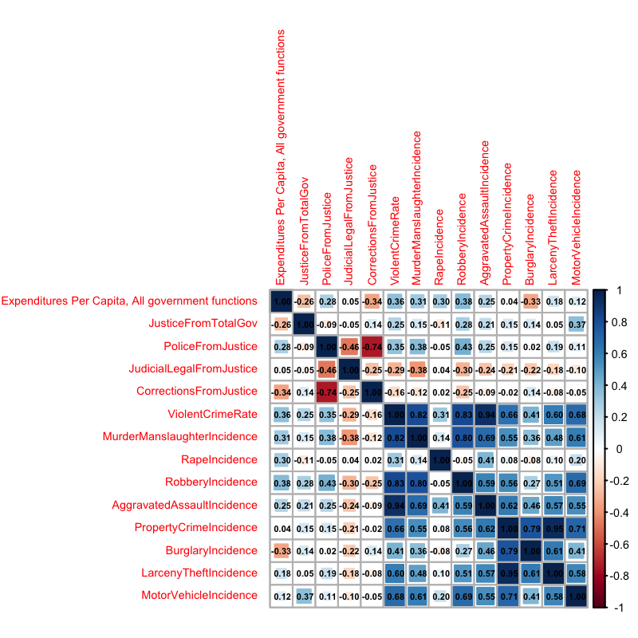
The correlation matrix above illustrates the linear relationships between 14 different variables included in this analysis. Inside each box is a Pearson correlation coefficient, or “r-value,” which ranges between -1 and 1 depending on the “direction” and “strength” of the linear relationship between two variables. A negative correlation coefficient between two variables signifies that as one of the variables increases, the other variable generally decreases. A positive correlation coefficient signifies the opposite, meaning that both variables typically increase or decrease at the same time as each other. An r-value of zero means that there is absolutely no quantified linear correlation between the two variables at all. As negative r values get closer to -1, and positive r-values approach +1, the level of covariance between a random assortment of data points would be expected to decrease, and the data will tighten closer along the line of best fit.
A number of insights can be derived from the information provided by the correlation matrix that was created above. Perhaps the most apparent observation is that the nine different crime categories derived from the FBI’s NIBRS program almost all have a positive linear relationship. The only exception appears to be incidence levels of rape, which do not seem to have a strong linear relationship with any of the other 13 variables included.
Another noteworthy piece of information that can be derived from this matrix is that there is a positive correlation coefficient between the portion of total government expenditures allocated towards the justice system and 8 out of the 9 crime classifications listed. This suggests that states that devote a larger portion of their budget towards the justice system actually face higher levels of criminality. However, this does not automatically mean that there is a causal relationship between any these variables. Further analysis would be required to assess the benefits and drawbacks associated with determining how public sector funds should be allocated in order to reduce levels of crime.

However, the linear relationships appear to be relatively weak, as they range between -0.11 and +0.37.

appears to be a high level of among the data points likely a high level

UNFINISHED PROJECT

Ten Year Percent Change (2007 – 2017)
